FRENCH AT A-LEVEL
Resources
At CCHSG, we use the AQA AS & A-Level French textbook from OUP which is also available online (Kerboodle). This gives students the opportunity to access the resources on any device. Consequently, students can work independently and at their own pace. The department also produces other materials such as an Information Booklet and a Speaking Booklet. The Language Assistant also produces her/his own resources to be used in study support.
Classes
Lessons are taught by 2 teachers. In Year 12, Teacher 1 works on Music, Family, Cinema, and the film La Haine and Teacher 2 works on Heritage, Technology and Volunteering. In Year 13, Teacher 1 will carry on with the film analysis and topics such as Multicultural society and Immigration. Teacher 2 will introduce the literature text, No et Moi, and will work on topics such as Demonstrations and Strikes. Teacher 2 will also introduce the Individual Research Project although both teachers will spend some time on it. Classes are usually small so this means, there is time for 1:1 discussion and feedback. Students are timetabled at least once a fortnight in the Language suite (T13).
Foreign Language Assistant (FLA)
Our FLA works mainly with A-Level and GCSE students either on a 1:1 basis or in a small group. In A-Level, our students are time-tabled for a half an hour slot with the FLA every week and are supported by them in their study support as well. Students have found it highly beneficial to be able to communicate with a native speaker outside the classroom.
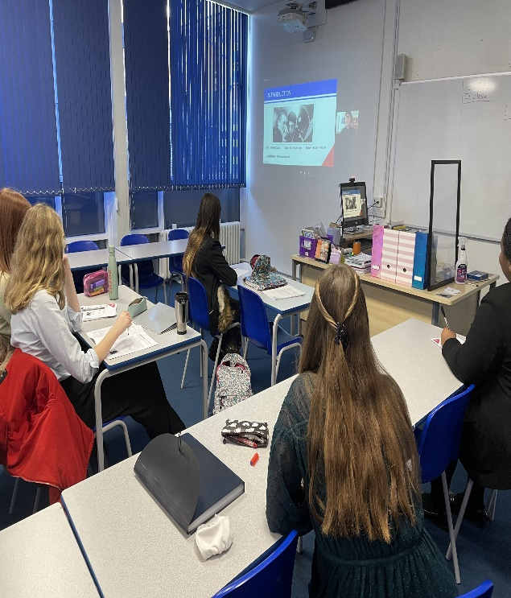

Enrichment
In order to integrate into school life and to make the most of their time in the French Department, we highly encourage students to take part in extra-curricular activities. After all, French is not just a written language!!! Our Year 12 are involved in several activities namely:

Mentoring/Language Ambassadors:
They help promoting French by supporting younger students at lunchtime with their learning and understanding of the language.

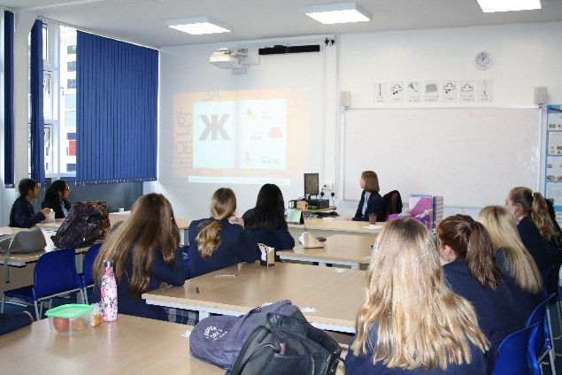

Word of the month:
Each month, they take a closer look at words from our French dictionaries and focus on one word. This is then promoted around the school through different media.

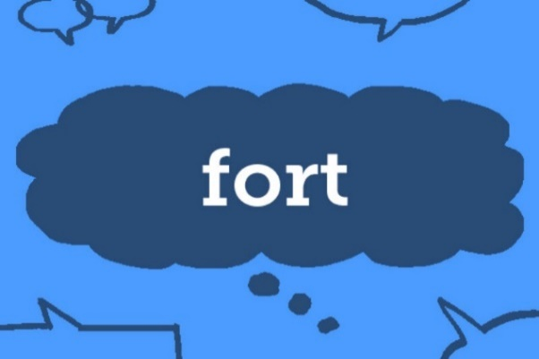

Language, Culture and Diversity Week:

The Big MFL Quiz : A form time activity put together by our Language Ambassadors.

The Languages Assembly: Students deliver an assembly to the whole school entitled Languages and Beyond where they talk about the reasons why they choose to study a language in sixth form.
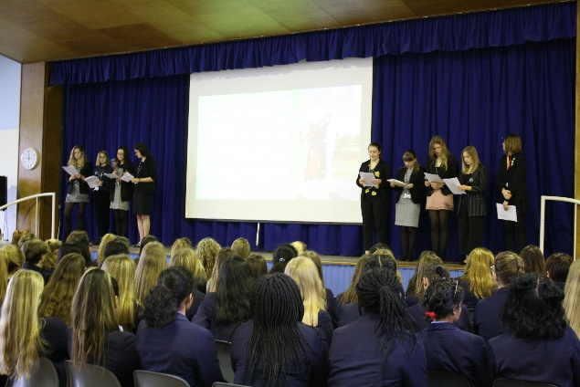

The MFL’s Got Talent Show. During that week, our Yr 12 students put on a play, which they perform in. Usually they choose a play which the rest of the school can understand but add their own twist to it. So far, we’ve adapted and played Blanche Neige, La Belle et la Bête Shrek, un spectacle musical and High School Musical. This year, they will be performing in Ratatouille in March. The play has a huge impact on their confidence building and teamwork, without mentioning the benefits on their speaking skills.

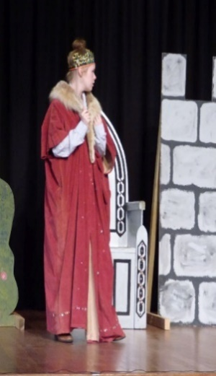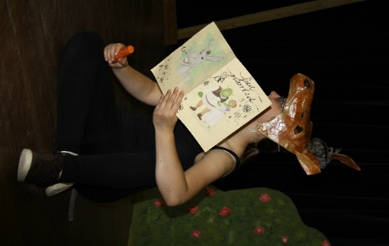
ALUMNAE
Maddie: BA Photography, Falmouth University
I studied French, English and Art at A Level. I went to Falmouth university in Cornwall to Study BA photography which I graduated with a first class honours. My French A Level has helped me in many aspects of my life, with a love for France and frequently travelling there, and also in my photography practice. It is a great tool to have and puts you in a great position for employment and travelling too. I personally included French within my degree through French poetry. I created a photo book with photographs accompanied by French and English poetry. My work won a Gold award in London last summer and I think having the French connecting and aspect to my work helped me achieve this. I continue to work on this project and include French inspiration within my practice. I also enjoy learning about culture and tradition, French A Level is a great way to do this. It equips you with new skills, speaking and literature that can transfer into your life.
Amy: MSc Biology, University of Oxford
I studied French, Biology and Physics. I then went on to study Biology at Oxford, where I specialised in conservation and sustainability. As part of my Master's, I spent a month researching elephant seismic communication in Kenya, working with researchers from all over the world. With many of my co-workers being French speakers, this initially biology-oriented project led me to draw on skills from all three of my A-Levels. This has come in incredibly useful over the years, in a range of scenarios: travelling, meeting new people and even in the workplace! I now work as a sustainability consultant for The Carbon Trust, and, thanks to my language skills, am able to work with the EU team and their French clients. Having French as a base has also proved incredibly useful in terms of understanding new languages - despite my Spanish being atrocious, I've been able to get by in Spanish speaking countries, as a result of both languages having similar origins. I'm so glad I took French for A-Level, and will always miss our sixth-form lessons.
Christina: BA French & German, King’s College
I finished my A-Levels in French, German and History. I then went on to study French and German at King's College London. I graduated with my Bachelor's degree this summer and am now working as an English Language Assistant in Vienna. A-Level French provided me with the confidence to pursue my degree, since there was a lot of support and focus on individual progress. It also led me to explore current and complex social issues through various forms of media, such as film. This then motivated me to take a film module at university and attend various French film screenings in London.

Ella: BA Law, University of Cambridge
I studied French, Economics, English and History. I have first class BA in Law from University of Cambridge and distinction on Bar Vocational Course from City University. I have been called to the bar by Middle Temple. I currently work as a paralegal at Peters May LLP, assisting on the full range of family law matters. I will be commencing pupillage at 1 Kings Bench Walk - the final step to becoming a barrister. Studying French at A-level has encouraged me to push myself out of my comfort zone when communicating with others. It gave me interpersonal skills, which are invaluable as a barrister, in dealing with a range of different clients and being empathetic to their needs. Further, through French, I have gained an ability to articulate my arguments fluently and with confidence which is crucial both on a client level and when delivering oral submissions in court. Studying French at A level has undoubtedly helped me in so many ways and equipped me well for a career at the Bar.
Riannon: BA History, University of Cambridge
I studied French, English Language and History at A level, and graduated from Cambridge in with a degree in History. I was able to read primary and secondary sources in French, which expanded the horizons of what I could study and enriched my understanding of the past. I specialised in gender history, and especially enjoyed researching French women’s experiences of the Revolutionary Wars in my final year, as I could read their stories in their own voices. I also still use French-language news outlets, as I now work at the BBC and I’m training to become a journalist. I know the language skills I learnt at CCHSG will continue to expand my horizons going forward.

Ellee: French and Linguistics
University of Oxford
I studied French, Psychology, and Biology. The knowledge I gained during my French A-level has been super helpful and applicable: the speaking practice allowed me to develop that skill and feel more confident when speaking to native speakers during my year abroad in Paris, and the exposure to literature and film gave me a good base to further expand upon through my degree, and gifted me with the opportunity to enjoy novels in another language. My favourite part of French was and still is the speaking, as it connects you with people in different cultures. During my year abroad I've made unforgettable memories and friends for life, and that wouldn't have been possible without the French A-level starting it all off. I actually stayed in my friend’s apartment when I first moved to Paris, who was the student I was paired with in year 12 through CCHSG's French exchange programme in Lyon! On top of that, we studied the topic of French heritage in the A-level textbooks, and there was an extract on Mont Saint-Michel, a famous pilgrimage site in the Normandy region. I finally visited it during my year abroad!

Poppy: French and Spanish
University of Cambridge
I left CCHSG in 2022 after studying French, German, and English Language at A-Level. I honestly cannot recommend languages A-Levels enough. Firstly, academically, French A-level improved my French enormously - the improvement in my speaking was so satisfying and rewarding, and I had so much support and encouragement from my teachers. I found it quite different from GCSE French in the best way. The course is very useful for real life conversation, and we studied a book and film which I really enjoyed.
Looking back, my French classes were a highlight of my week. The small class sizes meant we had lots of time for interesting discussion and our lessons had such a relaxed atmosphere, even though we were improving so much with each topic. Since the UK’s exit from the European Union, I want to use my multi-lingual ability as a unifying force. I’ve always loved doing French outside school and I think it’s a good way to connect different countries. I’m really excited about doing languages and being with other people who are passionate about the subject.

BONNE CHANCE !

The French Department

