Economics A-Level Transition Workbook

This transition pack will provide you with a brief outline of the course structure and a reading list of sources and videos. You may wish to use these sources before and throughout the course to improve your wider understanding. This pack also contains some interesting activities to get you thinking ready for the first few weeks of the course.

If you have never studied Economics before, you probably do not know too much about Economics at this stage. The 2008/09 global recession, Eurozone crisis, BREXIT and COVID-19 means that there are always interesting articles appearing in the news for you to follow.

Economics is a challenging, technical and theoretical subject, and to be successful you will need to have a thorough grasp of the theory covered at A-Level. However, the more you can place economic theory in real world scenarios, the better you will be able to evaluate ideas and give yourself the chance of attaining top grades. You will also personally get more out of the course if you have a good understanding of the prevailing economic climate in the UK, across Europe and in a global context. This pack gives you some ideas of how you can keep up to date.

You have two tasks to work on over the summer. These should not take up too much of your time but will hopefully get you thinking about two Economics issues that are going on in the UK right now. As you think about the questions, always think about the reasons that justify an opinion.

Basic course overview:
You will study the AQA Economics 2015 course over 2 years which is assessed at the end of this time by 3 examinations. The basic overview of the course content can be seen below:

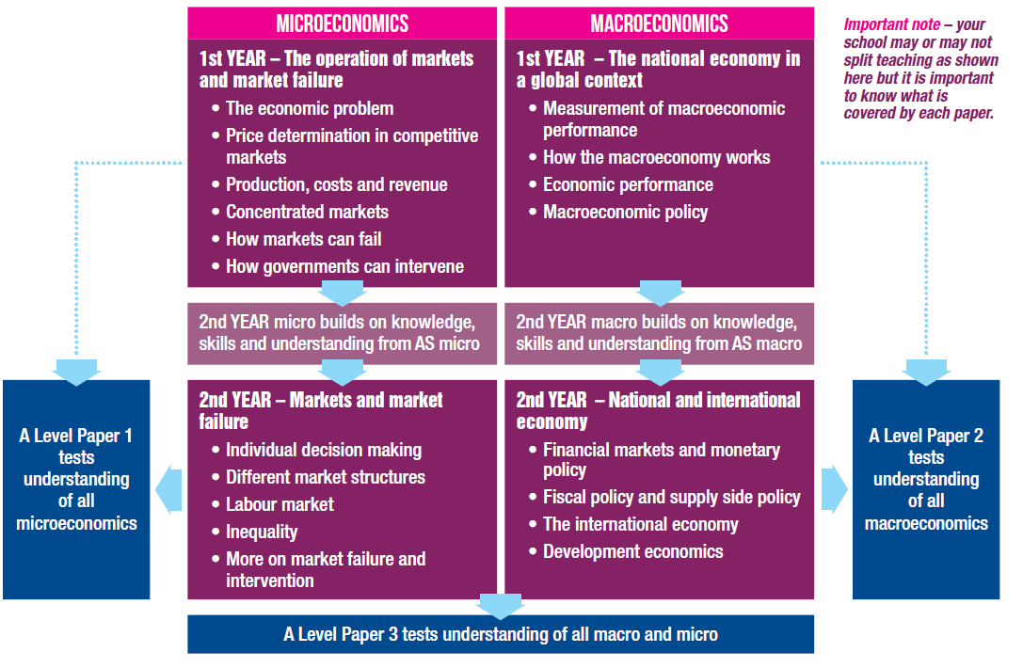

Task 1: Macroeconomics – GDP, the economic cycle and unemployment
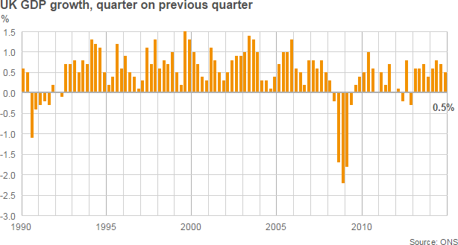

GDP & Recession
All countries experience regular ups and downs in the growth of output, jobs, income and spending.

Gross domestic product (GDP) is a measure of a country's economic activity, including all the services and goods produced in a year. It is based on a huge survey of businesses and government departments compiled by the Office for National Statistics

An economy is generally considered to be in recession if GDP falls (contracts) for two consecutive quarters i.e. 6 months. A recession means a fall in the level of real national output i.e. a period when growth is negative, leading to a contraction in employment, people’s incomes, and firm’s profits.

In 2014 the UK's economy was in recovery and grew by 2.6% in 2014, the fastest pace since 2007 and up from 1.7% in 2013. For 2015, GDP growth was down to 2.2%. The last quarter of 2015 saw GDP growth of only 0.5%, a three-year low. This was after the 2008/09 global recession which saw the UK economy contract, seeing the worst negative periods of GDP growth since 1979.

A recovery occurs when real GDP picks up from the trough reached at the low point of the recession. The state of business confidence plays a key role here. Any recovery might be subdued if businesses anticipate that it will be temporary or weak in scale.

A recovery might follow a deliberate attempt by the government to stimulate demand. In the UK we have seen:
- Cuts in interest rates – the policy interest rate fell to 0.5% in the Autumn of 2008 and they have stayed low ever since (as of 2020).
- A rise in government borrowing.
- A policy of quantitative easing (QE) by the Bank of England to pump more money into the banking system in a bid to increase the supply of loans – now worth more than £375 billion.

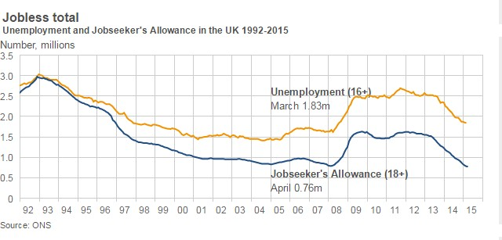

Unemployment
A few months after the start of the recession in 2008, unemployment started to rise sharply. When the global financial crisis hit, the unemployment rate was a little over 5% or 1.6 million. Towards the end of 2009, with the UK coming out of its severest recession since the 1950s, it was almost a million higher at 2.5 million, or 8%. Unemployment peaked at almost 2.7 million at the end of 2011, its highest level for 17 years. Unemployment fell by 102,000 to 1.86 million in the three months to the end of January 2015, according to the latest Office for National Statistics (ONS) figures. The number of people claiming Jobseeker's Allowance in February fell by 31,000 to 791,200, its lowest level since 2008. The employment rate now stands at 76.6%, the highest rate of people in work since the ONS began keeping records in 1971. A person is classed as unemployed if not only out of work, but also actively looking for work and available to start work within a fortnight.

Government Policy

The Conservative government, after being elected in 2015, have pursued a policy of reducing the budget deficit through a range of spending cuts known as austerity. Before the election, the Labour Party were proposed that cutting government spending too quickly would harm the British economy and felt to encourage economic growth, the government should spend, to create jobs and therefore more spending would boost the economy further aiding economic recovery.

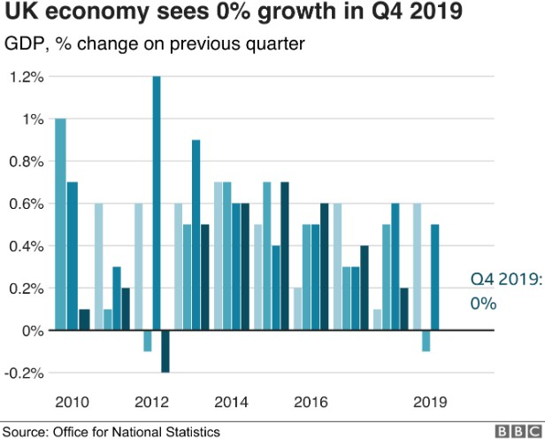
Article 2: UK economy saw zero growth at the end of 2019
(11 February 2020)

The UK economy saw no growth in the final three months of 2019, as manufacturing contracted for the third quarter in a row and the service sector slowed around the time of the election. The Office for National Statistics (ONS) said the car industry had seen a particularly weak quarter. The ONS figures also showed the economy grew by 1.4% in 2019, marginally higher than the 1.3% rate in 2018. Recent surveys have suggested that the economy has picked up in the new year.

How worried should we be?

Ruth Gregory, senior UK economist at Capital Economics, suggested that the flat growth seen at the end of the year would "prove to be a low point". She added: "The pick-up in the surveys of activity and sentiment suggest the first quarter will be much better. "The GDP figures were not quite as bad as we had feared in quarter four. The stagnation in GDP beat our forecast of a 0.1% quarter-on-quarter fall."

In December alone the economy grew by 0.3%, the ONS said, reversing the decline seen previously in November. "It's likely that political uncertainty and unwinding stockpiles caused the economy to flag at the end of last year," said Tej Parikh, chief economist at the Institute of Directors. "However, firms entered 2020 with more of a spring in their step. Confidence has shot up, while hiring plans and investment intentions have also risen a notch, but the post- election bounce may tail off."

Which sectors performed poorly?

Rob Kent-Smith, the ONS's head of GDP, said: "There was no growth in the last quarter of 2019 as increases in the services and construction sectors were offset by another poor showing from manufacturing, particularly the motor industry." The services sector - which accounts for more than three-quarter of the UK economy - grew by just 0.1% in the final quarter of 2019, while the construction sector grew by 0.5%. However, the manufacturing sector saw output fall by 1.1%. That came after some car factories paused work in November in case Britain left the European Union without a deal on 31 October. The ONS revised up the growth figure for the third quarter of 2019 to 0.5% from its previous estimate of 0.4%.

What about trade?

The last three months of 2019 also saw the trade deficit in goods and services widen to £6.5bn from the £4bn deficit seen between July and September. A deficit occurs when the value of a country's imports in goods and services exceeds what it exports. The deficit widened largely because of a shrinking of the surplus in UK trade in services. By contrast, the goods trade deficit shrank in the last three months of 2019. That was mostly accounted for by a £2.2bn decrease in machinery and transport equipment imports, which could suggest that orders might have been brought forward to avoid the (postponed) October Brexit deadline. For 2019 as a whole, the trade deficit for goods and services narrowed slightly by £0.5bn to £29.3bn.

Questions: (You will need to use the internet for research and write down your answers)

- What is GDP? (Useful link: https://www.bbc.co.uk/news/business-13200758)
- What is business confidence?
3) Research what caused the global recession of 2008/09? You could watch The Big Short to help
4) Explain three impacts of a recession or a slowing UK economy? Consider firms, workers & consumers
5) What can the UK government do to help an economy recover from an economic downturn (recession)?

What are interest rates? How do they impact firms & consumers? How might they help improve GDP?
- What is a budget deficit?
- Do you agree with the Conservative’s approach of reducing the budget deficit (Austerity) or Labour’s approach of spending to stimulate the economy? Justify your opinion.
- What is a trade deficit? How might it impact the UK’s economy?

Task 2: Microeconomics Minimum Prices

Minimum alcohol pricing plan 'may breach EU law' (BBC, 23 December 2015)

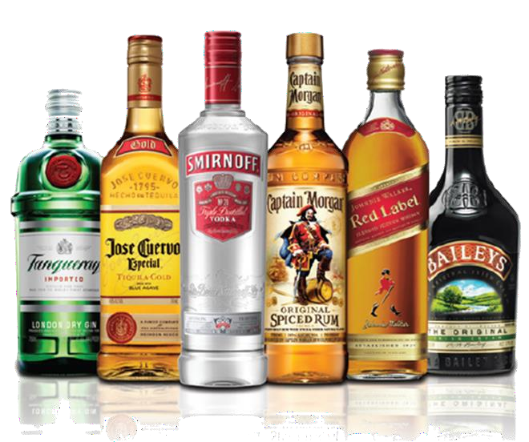
A European court has said the Scottish government's case for a minimum unit price for alcohol is contrary to EU law if other tax options exist.
the
The European Court of Justice ruling instead recommends introduction of alternative tax measures.

The Scotch Whisky Association (SWA) and First Minister Nicola Sturgeon have both welcomed the ruling. The legislation to bring in a minimum price of 50p per unit was passed by the Scottish Parliament in May 2012. A legal challenge was brought by the SWA, which argued the Scottish government’s legislation breached European law.

The European court ruling said: "The Court of Justice considers that the effect of the Scottish legislation is significantly to restrict the market, and this might be avoided by the introduction of a tax
measure designed to increase the price of alcohol instead of a measure imposing a minimum price per unit of alcohol." It added: "The court states that it is ultimately for the national court to determine whether measures other than that provided for by the Scottish legislation, such as increased taxation on alcoholic drinks, are capable of protecting human life and health as effectively as the current legislation, while being less restrictive of trade in those products within the EU."
Reacting to the judgement, Ms Sturgeon tweeted: "ECJ opinion on minimum pricing welcome. "We believe it is most effective way of tackling alcohol misuse. National court will now decide."

Health Secretary Shona Robison added: "This ruling from the Court of Justice of the European Union indicates, importantly, that it will be for the domestic courts to take a final decision on minimum unit pricing. "While we must await the final outcome of this legal process, the Scottish government remains certain that minimum unit pricing is the right measure for Scotland. We believe it is the most effective mechanism for tackling alcohol misuse and reducing the harm that cheap, high-strength alcohol causes our communities. "We maintain that minimum unit pricing would target heavy drinkers as they tend to drink the cheap, high strength alcohol that will be most affected by the policy. "The case will now continue to the Scottish courts, and we look forward to a hearing in the New Year to determine the outcome in this case."

David Frost, SWA chief executive, said: "The SWA always said European Union law issues were central to this case, and so it has proved. This settles EU law issues once and for all. "The court has confirmed that minimum unit pricing is a restriction on trade, and that it is illegal to choose MUP [minimum unit pricing] where there are less restrictive ways of achieving the same end. "The Scottish courts will now reflect on the implications of the ruling and all the evidence, before issuing a final judgement."
Analysis By BBC Scotland's home affairs correspondent Reevel Alderson
Plus ça change, plus ça même chose. Wednesday's ruling from the European Court of Justice (ECJ) is far from the end of a legal process which began in 2012 when the Scottish Parliament passed legislation allowing a MUP for alcohol to be set. The matter will now return to the Court of Session in Edinburgh, which had asked the ECJ to rule on whether MUP contravenes EU law. The Scottish judges will have to examine all of the evidence to help them decide whether improvements in public health - which the government says is the desired aim of MUP - could be achieved by other means, notably increasing tax rates. Ministers have argued that MUP would specifically hit high-strength alcoholic drinks which cause significant problems, particularly among young people. Whatever the Court of Session decides, it is almost inevitable there will be a further appeal to the UK Supreme Court, either by the Scottish government or the Scotch Whisky Association, whose challenge to the policy has halted its implementation.

Alison Douglas, chief executive of Alcohol Focus Scotland, said the ruling showed Scotland would be able to introduce minimum pricing "provided it is more effective than taxation". Ms Douglas argued minimum pricing was a better measure than alcohol taxes, which are "limited in their ability to raise the price of the cheapest alcohol to a level that will actually reduce harm". She also criticised the Scotch Whisky Association, saying it had "blocked the democratic will of the Scottish Parliament and sacrificed public health to protect their members' profits".

The chairman of BMA Scotland, Dr Peter Bennie, added: "The case for minimum unit pricing has always been based on the fact that it achieves what taxation cannot when it comes to reducing the harm caused by alcohol, so the decision of the European Court setting out the test that must be applied to the policy is a welcome one. "Today's ruling returns the case to the Scottish courts and puts Scotland a step closer to implementing minimum pricing."

'Unhealthy relationship' Scottish Health Action on Alcohol Problems (Shaap), which represents medical professionals, also welcomed the judgement. Shaap director Eric Carlin said it "effectively confirms that the Scottish minimum unit pricing policy has to be justified as a regulatory measure to work alongside taxation increases. "We hope that the Scottish courts will now move quickly to gather evidence to conclude this case and that the Scottish government will then implement this key policy without delay." Holyrood ministers have previously said minimum pricing was vital to address Scotland's "unhealthy relationship with drink". Under the plans, the cheapest bottle of wine (9.4 units of alcohol) would be £4.69 and a four-pack of 500ml cans of 4% lager would cost at least £4. It would mean a 70cl bottle of whisky could not be sold for less than £14.

Article 2: Minimum price 'cuts drinking by half a pint a week' (26 September 2019)

The introduction of minimum pricing for alcohol in Scotland appears to have cut drinking, a study suggests. Since May 2018, the price of alcohol has had to be at least 50p per unit. The study published in the British Medical Journal looked at how much alcohol was bought in shops before and after the move up to the end of 2018. It found the amount purchased per person per week fell by 1.2 units - the equivalent of just over half a pint of beer or a measure of spirits. The biggest fall was among the heaviest fifth of drinkers - the amount purchased by this group fell by two units.

Overall, Scots were still buying more than 14 units a week, the recommended limit, after the introduction of the new drinking laws. What is more, the analysis excluded pubs, bars, and restaurants, where about a quarter of drinks are purchased.

Impact 'bigger than expected'

Scotland was the first country in the world to introduce a minimum price based on the strength of alcoholic drinks. Research findings have led to calls for the policy to be adopted across the UK. Wales is looking to introduce minimum pricing in 2020, but neither England nor Northern Ireland currently have plans to set a limit.

Researchers, led by a team at Newcastle University, looked at how much alcohol people were buying in shops and supermarkets, but not in pubs. They analysed the purchasing habits of 60,000 English and Scottish households between 2015 and 2018. Just over 5,000 of them were in Scotland.

The English households were used as a control group to measure what would have happened if there had not been a minimum price in Scotland. While households in England increased their consumption slightly, Scottish purchasing fell. The study said overall it represented a fall of 7.6%, or 1.2 units, a week per adult on what would have been expected. The team said that was about twice the impact predicted ahead of the move.

Reductions were most noticeable for beer, spirits, and cider, including own-brand spirits and high-strength white ciders.

But the team acknowledged there needed to be longer-term follow up to see if the drop was sustained, as there was some evidence that in the later months of 2018 consumption had begun to rise again.

Lead researcher Prof Peter Anderson said: "You would expect some levelling off from the initial impact, but I think the findings are enough to suggest minimum pricing is effective and should be adopted across the UK."

Eric Carlin from the Royal College of Physicians of Edinburgh, agreed the evidence was compelling, but he said risky alcohol consumption was a "complex" public health issue.

"No single policy lever should be seen as a panacea," he added. Scottish public health minister Joe Fitzpatrick said the findings were "very encouraging".

Questions/Tasks:

- If available, watch the BBC Panorama documentary – Britain’s drink problem

- Why do consumers purchase different goods? What is utility in economics?

- What is supply and demand? How are market prices determined? What is a market equilibrium?

- What reasons do the government have for introducing minimum alcohol pricing?
5) In what ways might a minimum price on alcohol be considered ‘unfair’?
6) Do you think a similar minimum price should be introduced in England and Wales? (What three
reasons justify this opinion?) What impacts might it have?
7) Explain two different policies the government could use to achieve its aim of reducing alcohol abuse?

Reading List & Recommendations

Books, newspapers, magazines and online

Books

Introduction to economics books:

The Undercover Economist – Tim Harford - Introduces some basic economic concepts into real life scenarios.

Freakonomics – Steven Levitt - The economics of drug dealing, sumo wrestling and estate agents, amongst other things.

Some more challenging respected economics books which will enhance your knowledge in different areas of the course and you could talk about in a university reference. These are good to stretch yourself and give a more critical analysis of Economic study:

  - Economics: The User’s Guide (Ha Joon-Chang)
  - The Spirit Level: Why Equality is Better for Everyone (Richard Wilkinson & Kate Pickett)
  - Nudge: Improving Decisions About Health, Wealth and Happiness (Cass R Sunstein & Richard H Thaler)
  - Misbehaving: The Making of Behavioural Economics (Richard H Thaler)
  - 23 Things They Don't Tell You About Capitalism (Ha Joon-Chang)
  - The Big Short: Inside the Doomsday Machine (Michael Lewis)
  - Adapt: Why Success Always Starts with Failure (Tim Harford)
  - The Great Divide (Joseph Stiglitz)

Online
We recommend you follow useful business/economic news providers such as the BBC, Tuto2U, The Independent, The Guardian, The Economist, SKY News etc. Others such as The Times, Telegraph and The Financial Times are particularly good but limit your access if you do not pay for subscription.

Other good sources to read:
Revision guides such as the CGP Economics for AQA – AS & A2 Revision Guide
Economics Review magazine – Students will be able to subscribe to this when they start at The Burgate

A good quality newspaper (Particularly the business and Economy section) such as; The Guardian, The Times, The Telegraph, The Independent or the I for a more concise read.

Recommended Television shows/videos to watch
A good news programme (e.g. Channel 4 news at 7pm, Newsnight on BBC2 at 10.30pm)

BBC Question Time

BBC Panorama – www.bbc.co.uk/programmes/b006t14n - The long running BBC current affairs programme, featuring interviews and investigative reports on a wide variety of subjects but often economics related. In the past there have been relevant episodes such as The Big Squeeze, How to Survive the Meltdown and The Truth about Supermarket Price Wars. These documentaries are often available for up to a year after broadcast.
Economics related documentaries e.g. Dispatches

Listen to economics related radio programmes especially on the way into college and home again (e.g.
Today, PM, More or Less, presented by Tim Harford – weekly on BBC Radio 4, podcasts also available)

Films/Documentaries:
The Big Short (2015)

RBS: Inside the Bank that Ran out of Money (2011)
Inside Job (2010)
Margin Call (2011)

Enron: The Smartest Guys in the Room (2007)
The Corporation (2006)

Useful websites
https://www.youtube.com/channel/UCQbBh9Jn2IjcSPZOiNKJu0g Econplusdal - vital course videos explaining each topic
www.tutor2u.net – Tutor2u is an essential Economics resource for all students. It contains an excellent Blog with relevant news stories, exam advice and analysis of topical events. It also has various quizzes, revision notes and Power Points for free.
https://www.economicshelp.org/ - Economicshelp - Resources for those looking to understand economics. Essays, e-books, blog posts and latest developments on the UK and global economy.
www.bbc.co.uk/news/business & http://www.bbc.co.uk/news/business/economy - Keep up to date with current events in the economic & business world through the BBC website Business & Economy news section. Very easy to read and many helpful articles to gain real examples of the theory learnt in class. Vital for success in A2.
https://www.theguardian.com/business/economics & https://www.theguardian.com/uk/business - The Guardian newspaper Business & Economics section. Slightly more in-depth look at business current events and still free to access on-line.
http://www.independent.co.uk/topic/Economics & www.independent.co.uk/news/business - The Independent newspaper Economics & Business section. Another great source for Economics stories and again still free on-line.

