
A-Level Biology
A level Biology at CCHSG is an exciting, challenging and immersive subject. Biology is an exciting, rapidly advancing area of science that forms the basis of many important issues in today’s society and will take us into unknown areas in the future.
Biology is a very important A Level STEM subject highly regarded by universities as it develops a wide range of skills, such as analysing, evaluating, independent research and thought. It is preferred subject for many courses in higher education leading to degrees in Biological Sciences, Biochemistry, Molecular Genetics, Psychology, Pharmacy, Dentistry, Medicine, Veterinary Medicine and many other subjects. There are many Biological Science degree courses available, which are not only stimulating in their own right but provide entry to other careers including law, marketing, accountancy, the Civil Service and Industry.

A level biology at CCHSG

At CCHSG, you will be taught by two teachers and doing two topics in parallel. All the topics include practicals that will be assessed towards your Practical Endorsement.

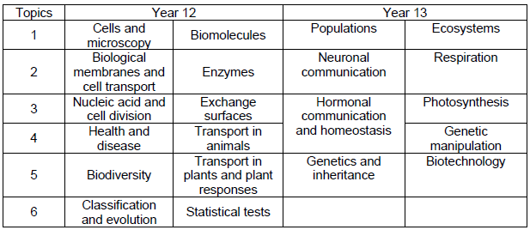

Fieldwork

We will attend a 4 day residential trip to Dorset to carry out field studies. This will include collecting and analysing data as part of your practical endorsement.

Support

The Biology staff is very enthusiastic and exited about their subject. We are very approachable and will help if you are struggling or if you need more help. Remember, A level Biology is designed to be more independent but if you need more support you must ask!

Supporting you to bridge the GCSE to A level Biology gap

Moving from GCSE to A level Biology can feel like a big leap. You will be expected to have a deeper understanding of each topics and learn a lot more facts, equations, and definitions. You will need to confidently use maths skills and apply them in unfamiliar situations.

Look through your GCSE notes. Revise tricky content.

Frequently in the news there are headlines concerning Biology such as stem cell therapies, cloning, genetic engineering, DNA evidence at crime scenes, zoonotic infections, biodiversity, infectious disease outbreaks and vaccinations.

Wider reading, watching documentaries and listening to podcasts.

Look ahead at the Biology A level course and the topics covered. What can you remember from GCSE?

Useful Links
- OCR A Biology Specification
- The Biology library on Khan academy
- Head Start to A-Level Biology (with Online Edition) | CGP Books
- A-Level Biology: Essential Maths Skills | CGP Books

News
- Biology - BBC News
- Biology - BBC NewsBiology News -- ScienceDaily
- Biology | The Guardian
- Biological sciences - Latest research and news | Nature

Wider reading. There is a book for everyone and every interest!

Medicine
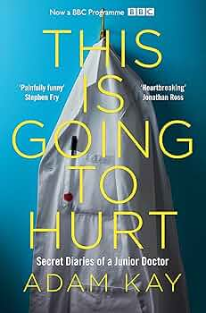
- Shapeshifters: a doctors notes on medicine and human change. Gavin Francis
- When breath becomes air. Paul Kalanithi
- Do no harm: stories of life, death and brain surgery. Henry Marsh
- Heart: a history . Sandeep Jauhar.
- This is going to hurt: secrete diaries of a junior doctor. Adam Kay
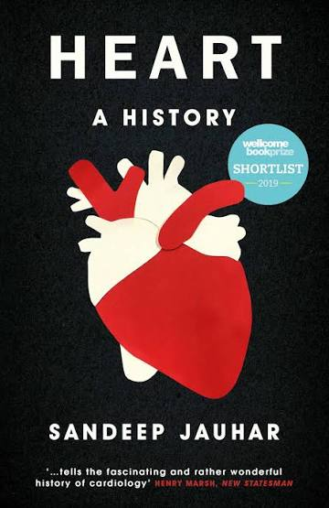
- The Immortal Life of Henrietta Lacks. Rebecca Skloot.
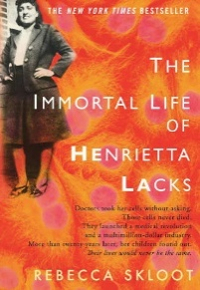
- Cancer: A Beginner's Guide. Paul Scotting.
- The story of a heart. Rachel Clarke

Genetics
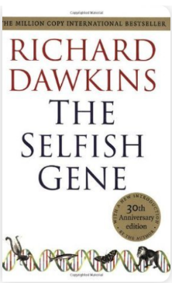
- The language of the genes. S. Jones.
- Genome. M. Ridley.
- Identically different: why you can change your genes. Tim Spector

Evolution
- The Beak of the Finch. J. Weiner.
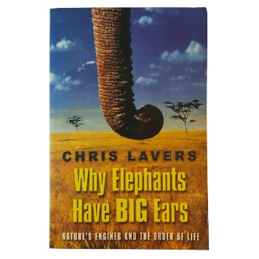
- Almost Like a Whale. S. Jones.
- The Selfish Gene. R. Dawkins.

Physiology
- Why Elephants Have Big Ears. C. Lavers.
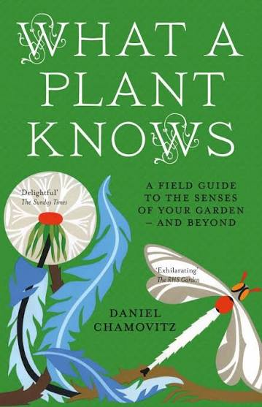
- The Energy of Life. G. Brown.
- Keep on Running. E. Newsholme.

Conservation Biology / Ecology
- Song of the Dodo: Island Biogeography in an Age of Extinctions. D. Quammen.
- The Future of Life. E.O. Wilson.
- What a plant knows. Daniel Chamovitz

Podcasts
- Biology: The Whole Story | University of Oxford Podcasts
- Bioscience Matters Podcast
- Big Biology Podcast
- Teach Me Biology | Podcast on Spotify

Complete the transition workbook during the summer holidays
- Link available separately on the website

